Exercise in Demand Curve

- Suppose tickets for football and handball matches are substitute goods. What would happen to demand for football games if the price for the handball games that take place on the same time would be reduced?
Answer:
If the price for handball games is reduced, the quantity demanded of handball tickets will increase (a movement along the handball demand curve, caused by handball’s own price change). Since football and handball are substitutes, the demand for football games will decrease (the football demand curve shifts left).
- Suppose that sports pay per view programs can be defined as a normal good. What would happen to demand for these programs if national income increases?
Answer:
An increase in income increase the demand for normal goods.
- Suppose an inferior good X. What should happen to its demand in case of an increased income?
Answer:
An increase in income decrease the demand for inferior (basic) goods.
- Suppose the following demand function: $Q^{D}$=9-p, where Q^{D} is the quantity demanded of a good and p is the price of a good in USD.

  - What would be the quantity demanded if the price is 1 USD?
  - What would be the quantity demanded if the price is 8 USD?
  - Suppose that the price is 3USD. What is consumer surplus?
Answer:
- $Q^{D}$=9-1=8
- $Q^{D}$=9-8=1
- The consumer surplus is the area between the demand curve and the price (triangle area) (9-3)*(6-0)/2=18
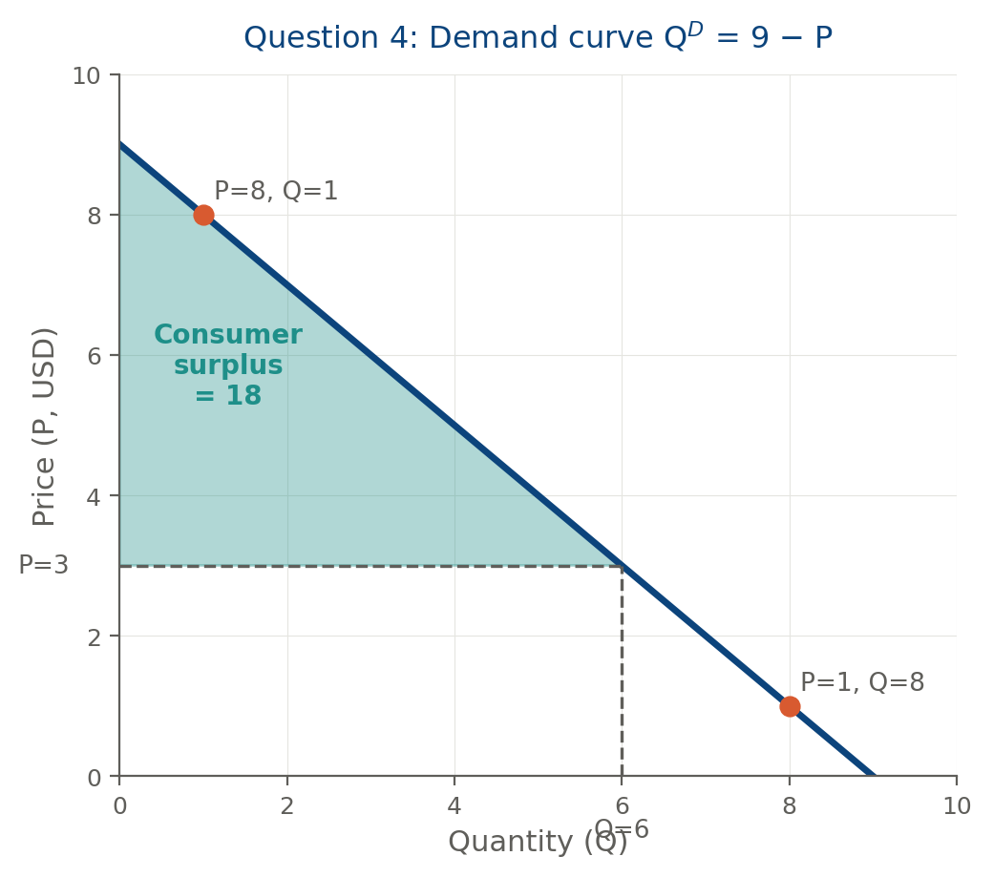

- Suppose the following demand function of a representative customer: $Q^{D}$=15-2p, where Q^{D} is the quantity demanded of a good and p is the price of a good in USD. Suppose there are 10 such customers. What is the aggregate demand?
Answer:
$10*Q^{D}$=10*(15-2p)= 150-20p
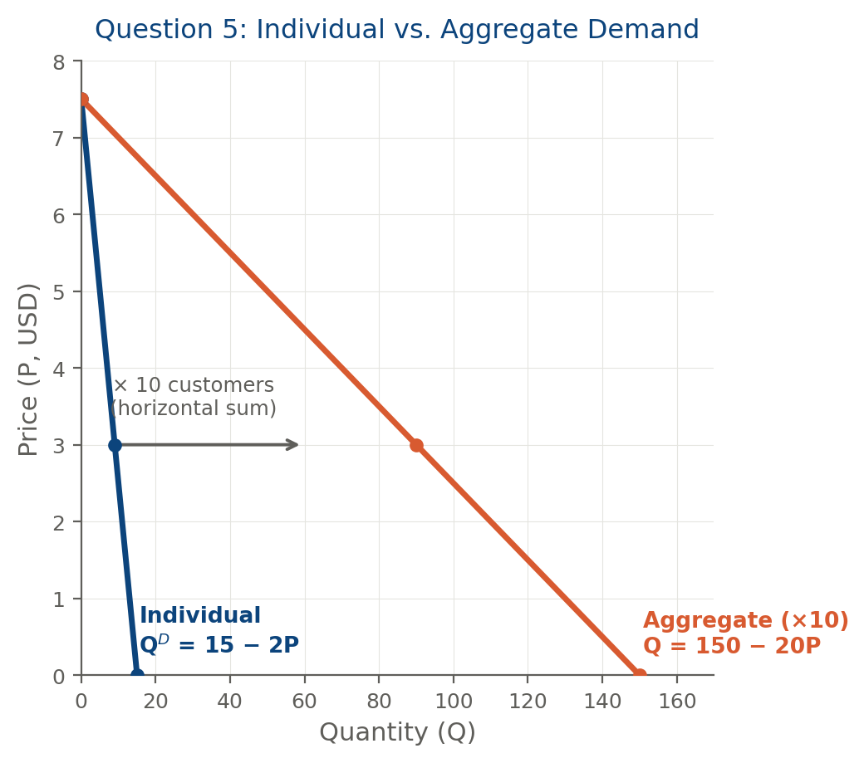
- Suppose an inelastic good X. Now suppose that the price of that good has increased. What will happen to the total revenues of the suppliers?
Answer:
An increase in the price of a good with inelastic demand will increase the total expenditure of consumers (total revenue of suppliers).

